**Objective:**

To understand the concept of exceptions and make appropriate uses of the system defined exceptions and/or create user defined exceptions and actualize them.

**Problem Statement:**

1.     Write a program to implement the concept of Exception Handling using **predefined exception.**

**CODE:**

import java.util.*;

import java.lang.*;

class Exception1 {

public static void main(String[] args) {

try {

int arr[] = new int[2];

System.out.println("Access third element : " + arr[3]);

} catch(Exception e) {

System.out.println("Exception thrown : " + e);

}finally{

System.out.println("This block is executed.");

}try {

int a = 5/ 0;

}catch(Exception e) {

System.out.println("Exception thrown : " + e);

}finally{

System.out.println("block after ArithmeticException is executed.");

}

}

}

**OUTPUT:**

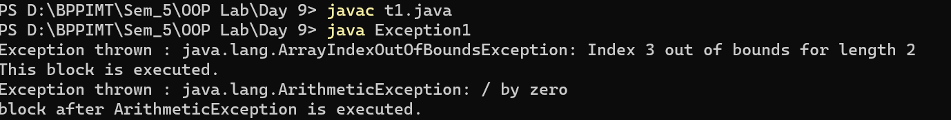

2.     Write a program to implement the concept of Exception Handling by creating **user defined               exceptions.**

NOTE: Use **throws, throw, try, catch and finally** keywords in your program.

**throw keyword :**

**CODE:**

class UserDefinedException extends Exception{

public UserDefinedException(String str){

// Calling constructor of parent Exception

super(str);

}

}

class Excep2{

public static void main(String args[]){

try{

// throw an object of user defined exception

throw new UserDefinedException("This is user-defined exception");

}catch (UserDefinedException ude){

System.out.println("Caught the exception");

// Print the message from MyException object

System.out.println(ude.getMessage());

}finally{

System.out.println("Program executed successfully!!");

}

}

}

**OUTPUT:**

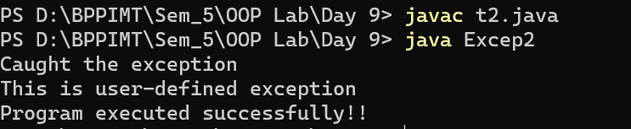

**throws keyword :**

**CODE:**

import java.util.*;

class myex extends Exception{

myex(String s){

super(s);

}

public String toString(){

return "sorry!! your age is less than required";

}

}

class Excep3{

public static void main (String args[]) throws myex{

int age=13;

if(age<18) throw new myex("not for under 18");

else System.out.println("welcome to vote");

}

}

**OUTPUT:**

